KENDRIYA VIDYALAYA SANGATHAN
SILCHAR REGION
SPLIT UP SYLLABUS
Session: 2014-15
Class: XI Subject: History
S.  No. | Name of the chapter | Month | No. of periods | Weightage of Marks | Test/Exam
1 | From the Beginning of Time | June | 48 | 15 | Unit Test I will include chapters 1 and 2
2 | Writing and City Life | July | 48 | 15 | Unit Test I will include chapters 1 and 2
3 | An Empire across three continents | August | 50 | 20 | Unit Test II will include chapters 3 and 4
4 | Central Islamic Lands | August | 50 | 20 | Unit Test II will include chapters 3 and 4
5 | Nomadic Empires | September | 50 | 20 | Half Yearly exam will include chapters 1 to 7
6 | Three Orders | September | 50 | 20 | Half Yearly exam will include chapters 1 to 7
7 | Changing Cultural Traditions | October | 50 | 20 | Half Yearly exam will include chapters 1 to 7
8 | Confrontation of Cultures | November | 50 | 20 | Half Yearly exam will include chapters 1 to 7
9 | The Industrial Revolution | December | 52 | 20 | Half Yearly exam will include chapters 1 to 7
10 | Displacing Indigenous People | January | 52 | 20 | Unit Test III will include chapters 8 and 9
11 | Paths to Modernization | February | 52 | 20
12 | Revision and Session Ending Exam | March |  |  | Session Ending Examination will include entire Syllabus.
13 | Map Work(All Units) |  | 10 | 5
14 | Project Work |  | 10 | 20
 | Total |  | 220 | 100
Note:-1.Value Based Question can be taken from any of the above Section- A , B, C, D----- 05 Marks. Accordingly, teacher can reduce weightage of the corresponding sections.
2. For detailed information related to completion of Project, go through the Guidelines given by CBSE(www.cbse.nic.in)

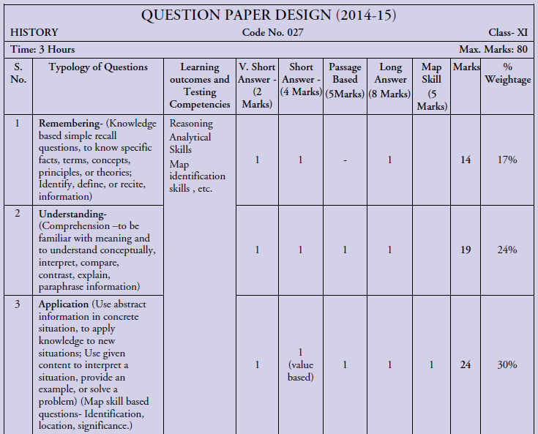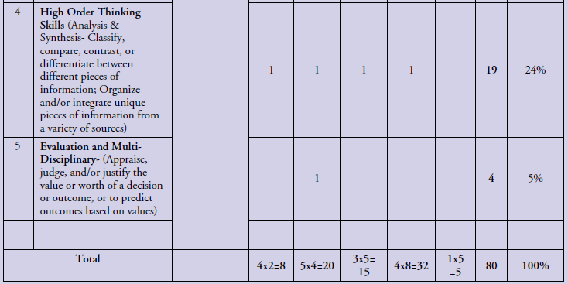

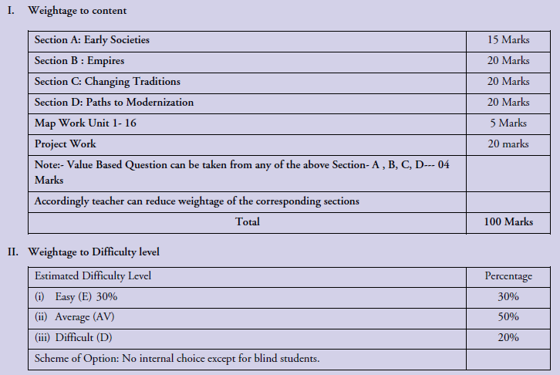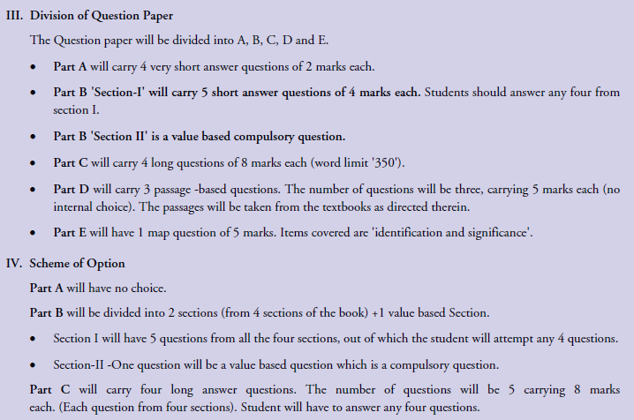
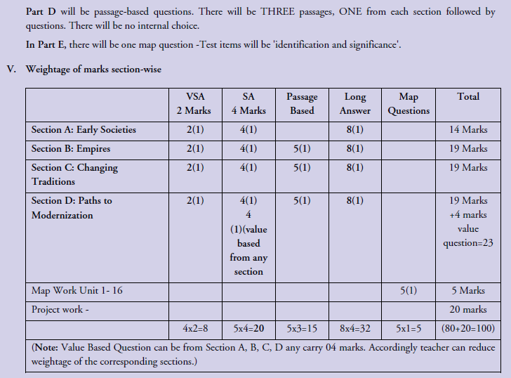

KENDRIYA VIDYALAYA SANGATHAN
SILCHAR REGION
SPLIT UP SYLLABUS
Session: 2014-15
Class: XII Subject: History
S.  No. | Name of the chapter | Month | No. of periods | Weightage of Marks
1 | Bricks, Beads and Bones (HarappanCivilisation) | April | 13 | 25
2 | Kings, Farmers and Towns | April | 14 | 25
3 | Kinship, Caste and Class | May | 14 | 25
4 | Thinkers, Beliefs and Builders | June | 14 | 25
5 | Through the Eyes of Travellers | July | 13 | 25
6 | Bhakti-Sufi Traditions | July | 13 | 25
7 | An Imperial Capital: Vijayanagara | August | 13 | 25
8 | Peasants Zamindars and the State | August | 13 | 25
9 | Kings and Chronicles | August | 13 | 25
10 | Colonial Cities(Urbanisation, Planning and architecture0 | September | 13 | 25
11 | Colonialism and the Countryside | September | 13 | 25
12 | Rebels and the Raj( 1857 Revolt and its Representatives) | September | 13 | 25
13 | Mahatma Gandhi and the nationalist Movement | October | 13 | 25
14 | Understanding partition(Politics, Memories and Experiences) | October | 14 | 25
15 | Framing the Constitution(The Beginning of New Era) | November | 14 | 25
16 | Map Work(All Units) |  | 10 | 5
17 | Project Work |  | 10 | 20
18 | Total |  | 220 | 100
Note: There is no change in the syllabus. Value Based Question can be from Part-1, 2, 3 textbooks and carry 04 marks. Accordingly teacher can reduce weightage of the corresponding sections.

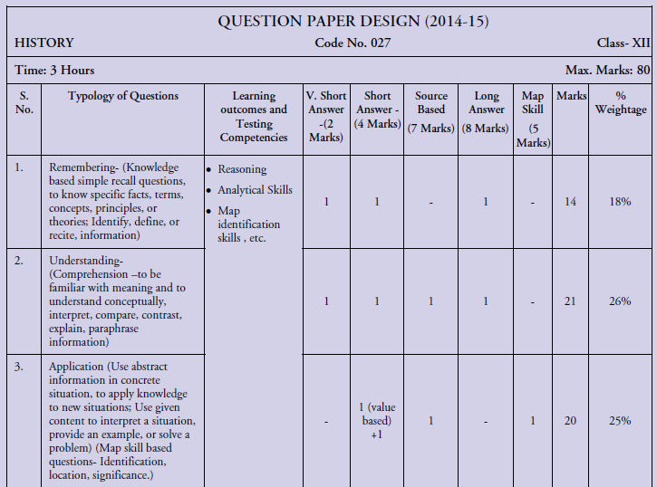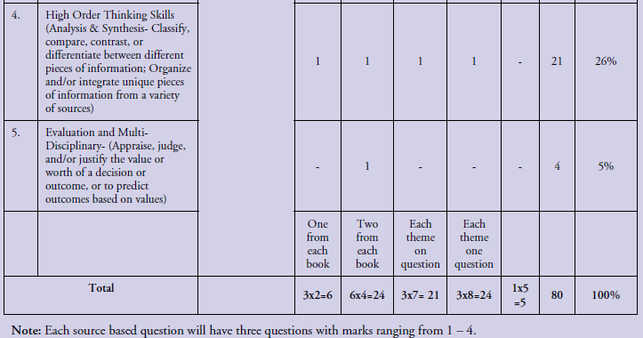
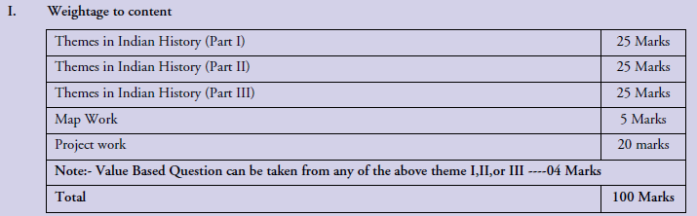
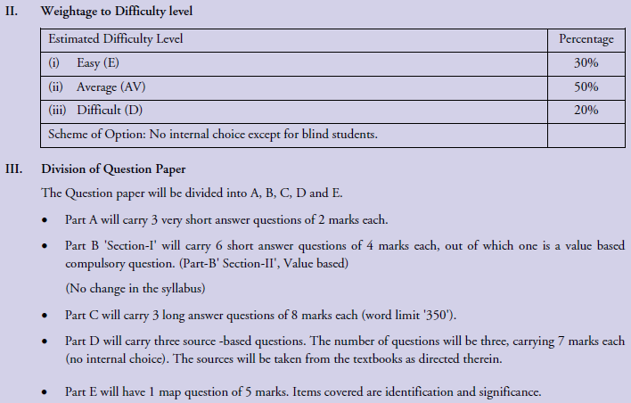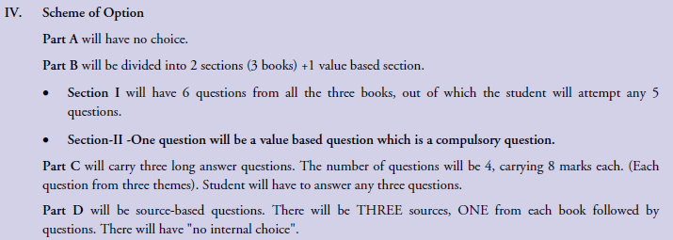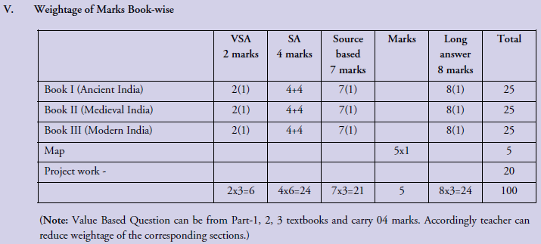
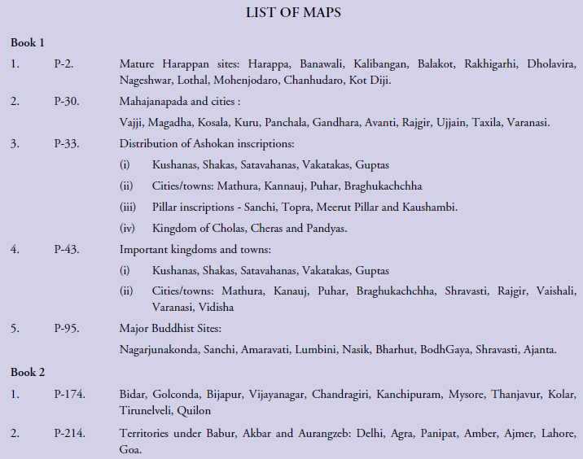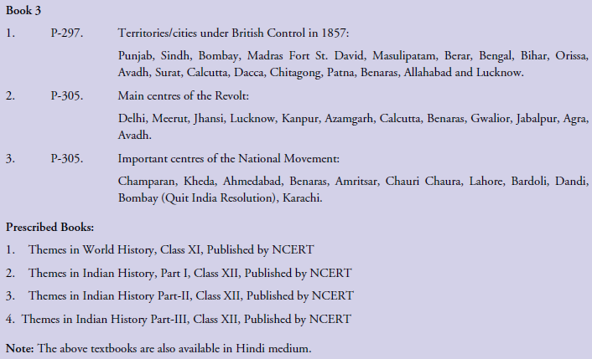

Mr. Madho Singh PGT(History)
KendriyaVidyalayaKunjabanAgartala

